Problem Statement: You work for XYZ Corporation. To maintain the security of the AWS account and the resources you have been asked to implement a solution that can help easily recognize and monitor the different users. Tasks To Be Performed:

1. Create 4 IAM users named “Dev1”, “Dev2”, “Test1”, and “Test2”.

2. Create 2 groups named “Dev Team” and “Ops Team”.

3. Add Dev1 and Dev2 to the Dev Team.

4. Add Dev1, Test1 and Test2 to the Ops Team.

Step-1)Created 4 IAM users named “Dev1”, “Dev2”, “Test1”, and “Test2”.

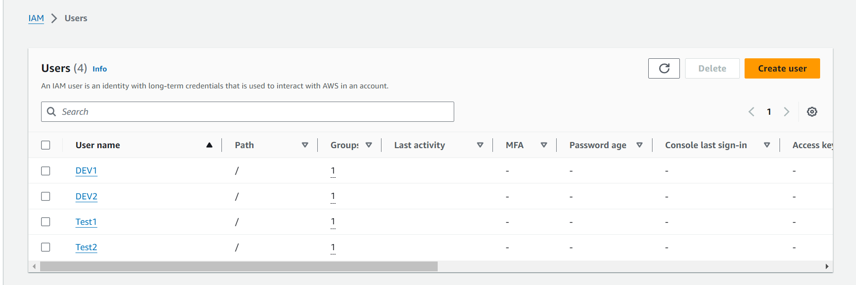

Step-2) Created 2 groups named “Dev Team” and “Ops Team”.

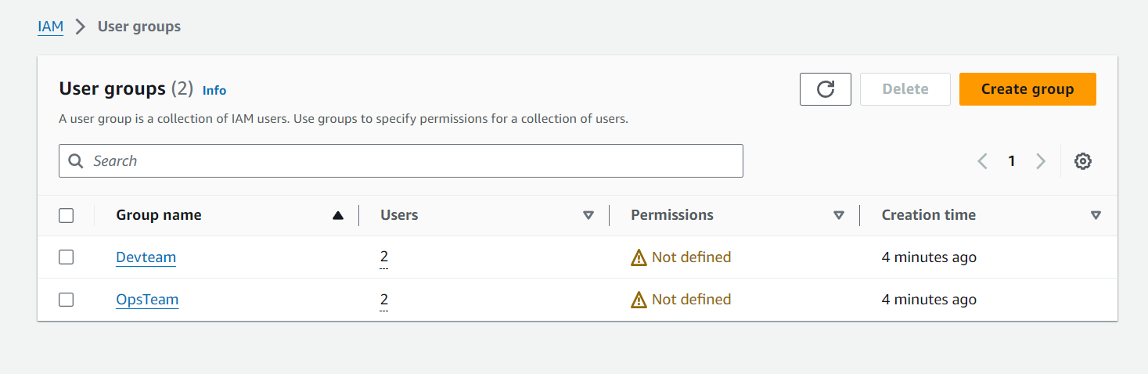

Step-3) Added Dev1 and Dev2 to the Dev Team.

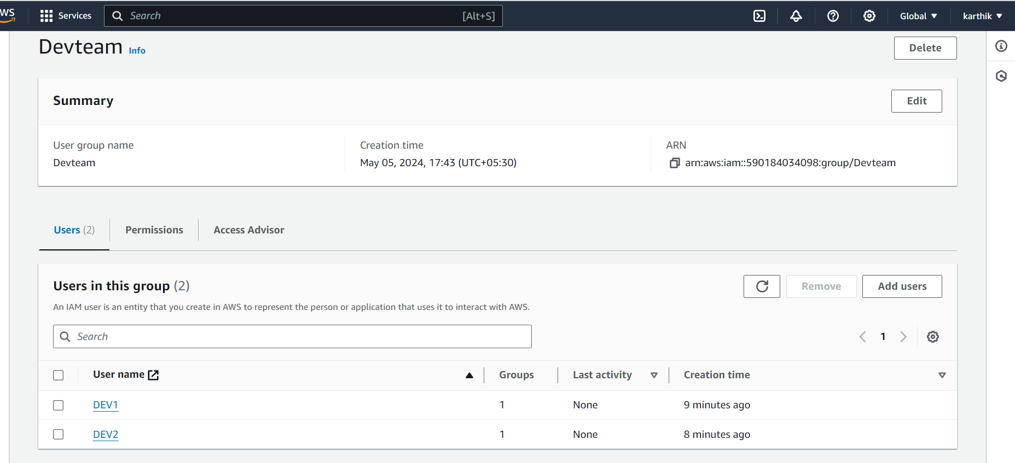

Step-4) Added Dev1, Test1 and Test2 to the Ops Team.

